**Weekly Status Update for Week6**

**Timeline:** Week6 (03-04-2024)

**What we have done:**

**Finished the deliverable 1: National Microcredential Framework Compliance**

1. **Frontend:** Updated the NFT request page, include all critical metadata and recommend metadata

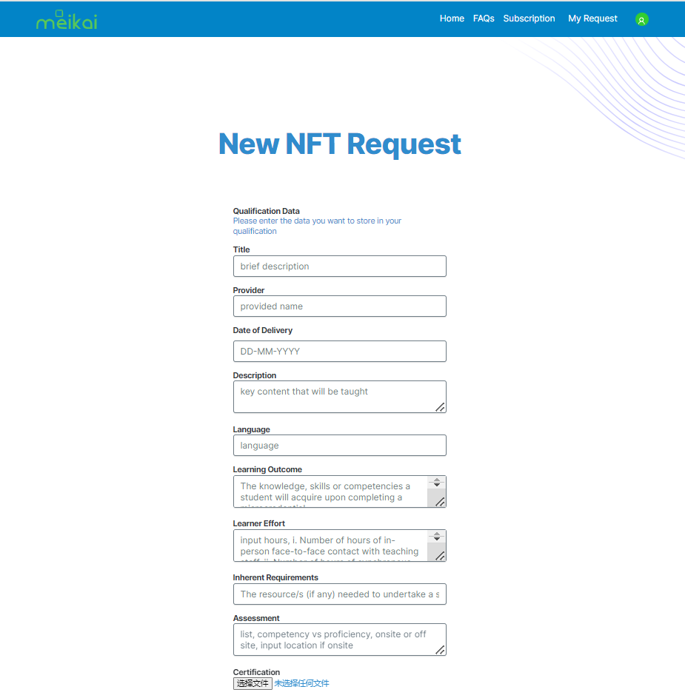

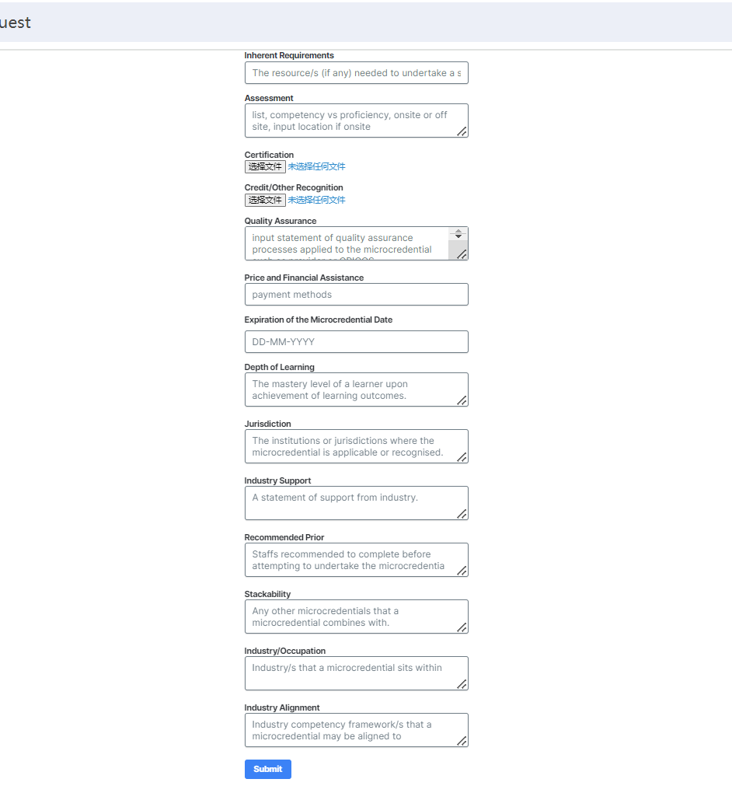

1. **Backend:**

* Implemented enhancements in OrderRequest, OrderServiceImpl, and Orderclasses and other classes to support extended order attributes (critical metadata and recommended metadata), including new fields in OrderRequest for comprehensive order details, updated OrderServiceImpl to handle creation and management of orders with new attributes, and modified Order entity to align with updated order management requirements.
* Fixed the Null variables issue in OrderRequest #184
* Add response message in backend for request list page #
* Now the backend can receive the whole metadata information, process it and send it back to the frontend without any problem.

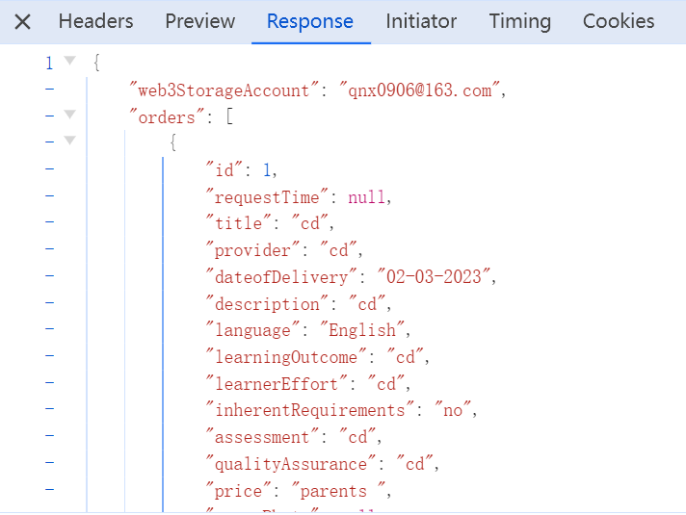

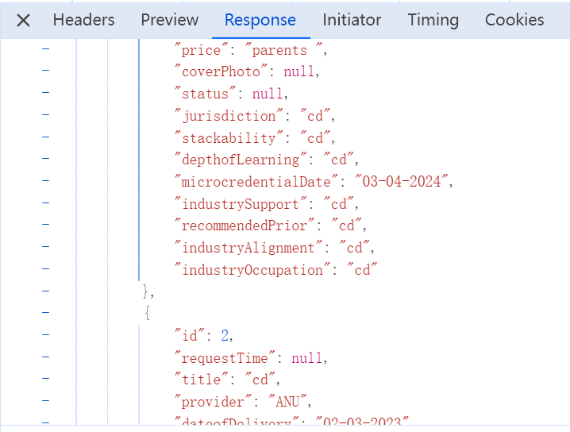

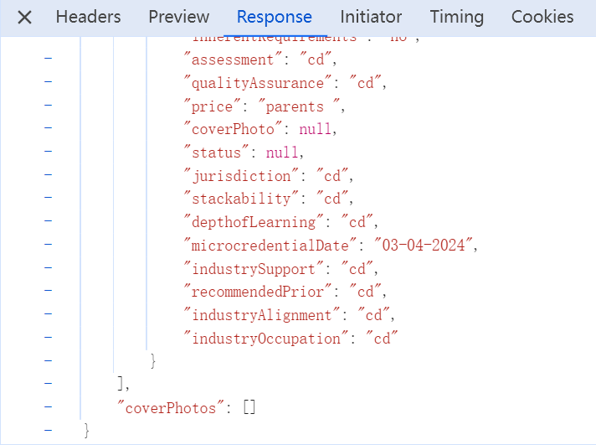

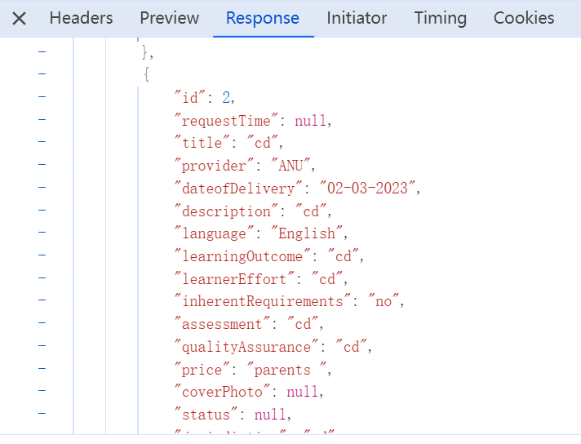

Database

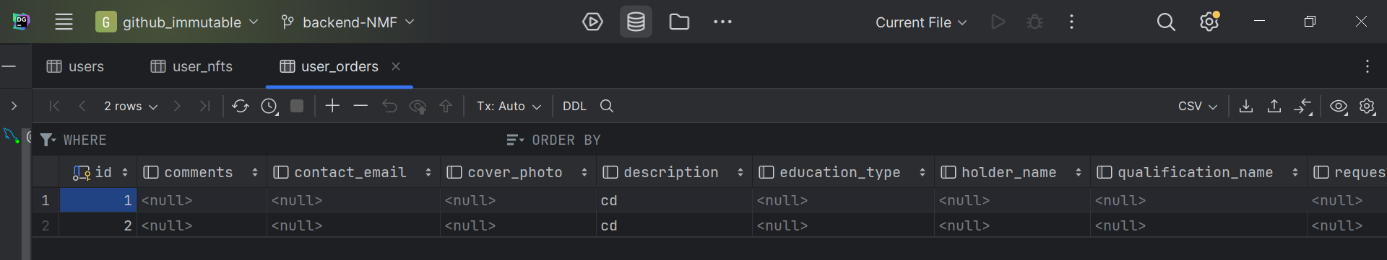

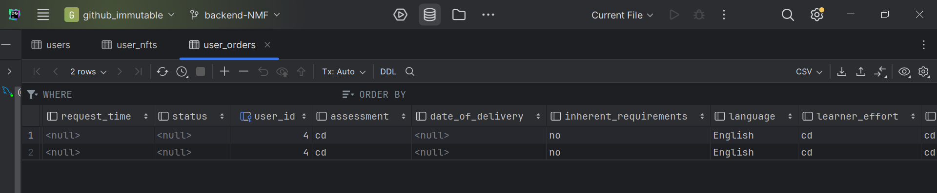

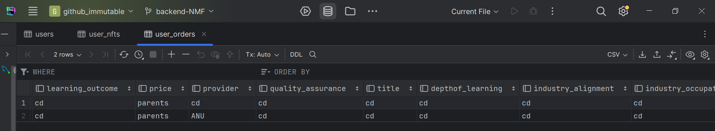

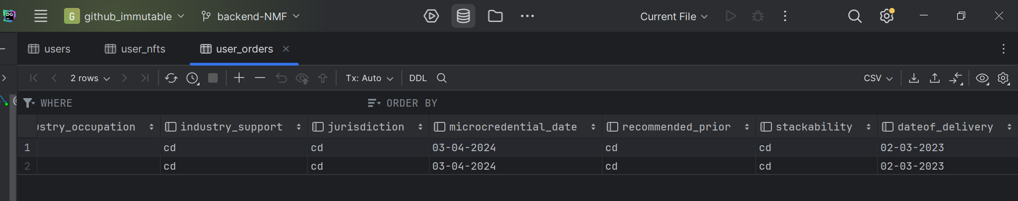

**What we will do next week:**

1. 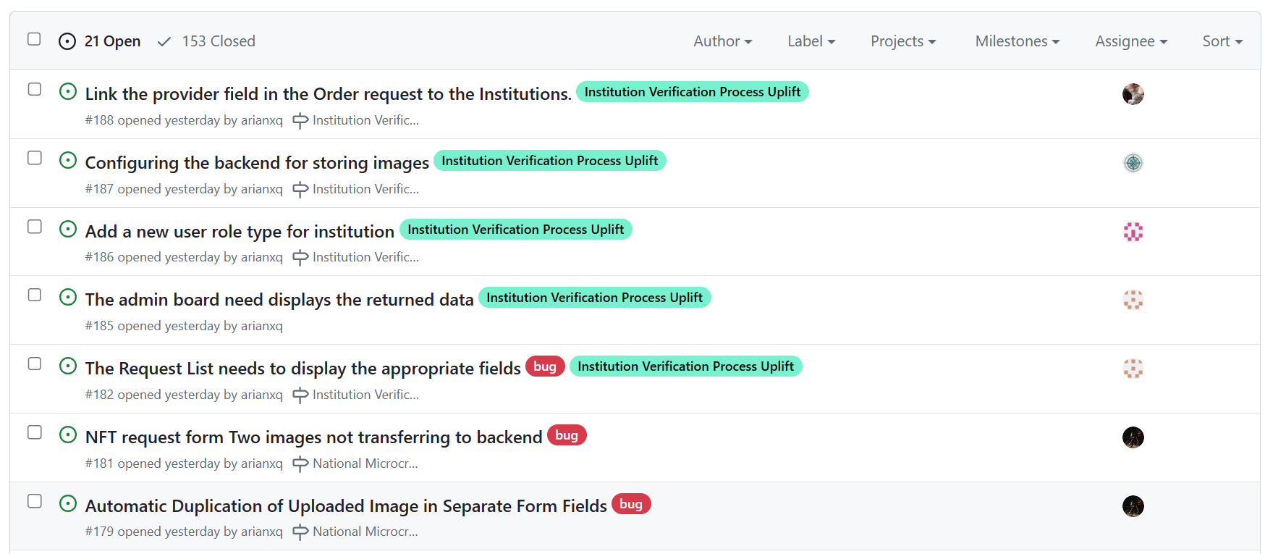
2. 